Denzel Fowler

Dr. Riazi

Database Design and Implementation

2 May, 2023

Final Report: Complete Database

**EERD**

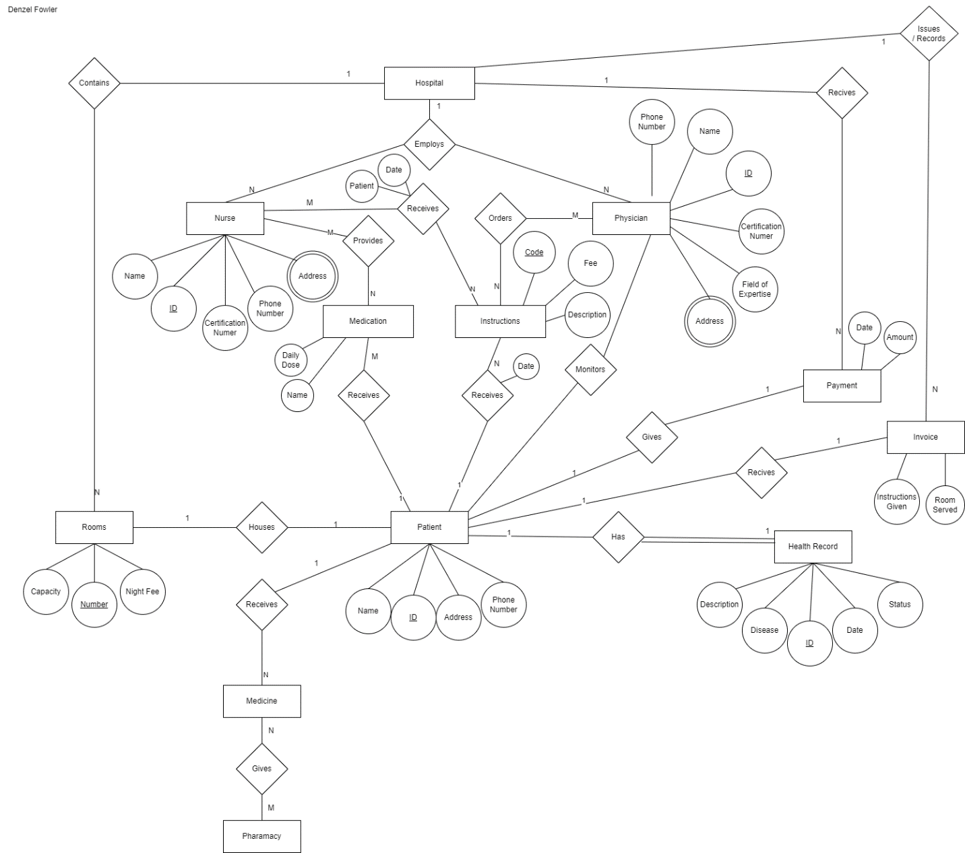

**Assumptions**

* A patient must be assigned to a physician
* Nurses must be assigned to an instruction
* Patients do not need to have a health record
* Patients do not need to be housed to a room

**Relations**

Primary keys:

Physician: ID

Nurse: ID

Patient: ID

Health_Record: ID

Instruction: Code

Room: Number

Foreign Keys:

Physician: ID

Nurse: ID

Patient: ID

Health_Record: ID

**Queries**

1. Look up patients name in alphabetical order

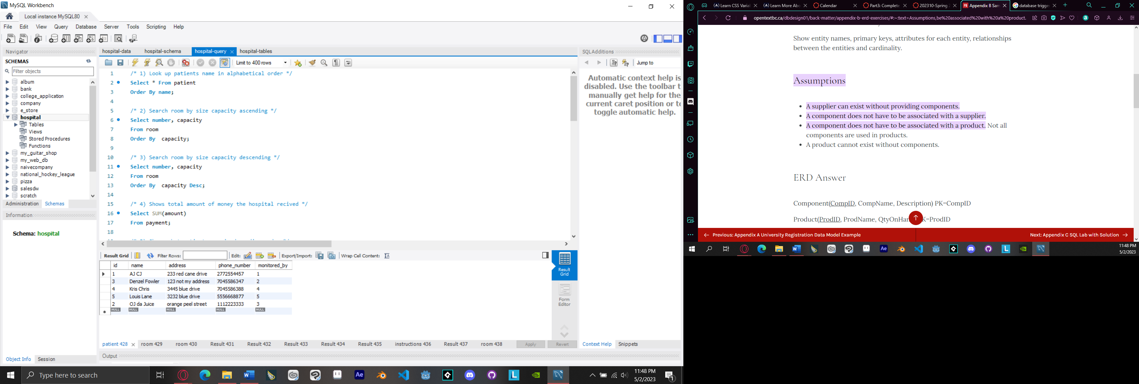

1. Search room by size capacity ascending

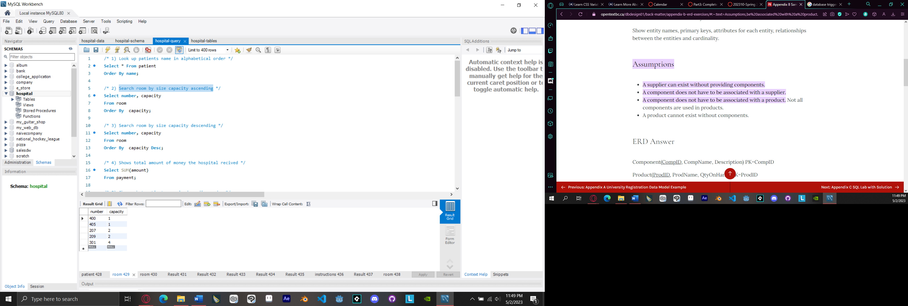

1. Search room by size capacity descending

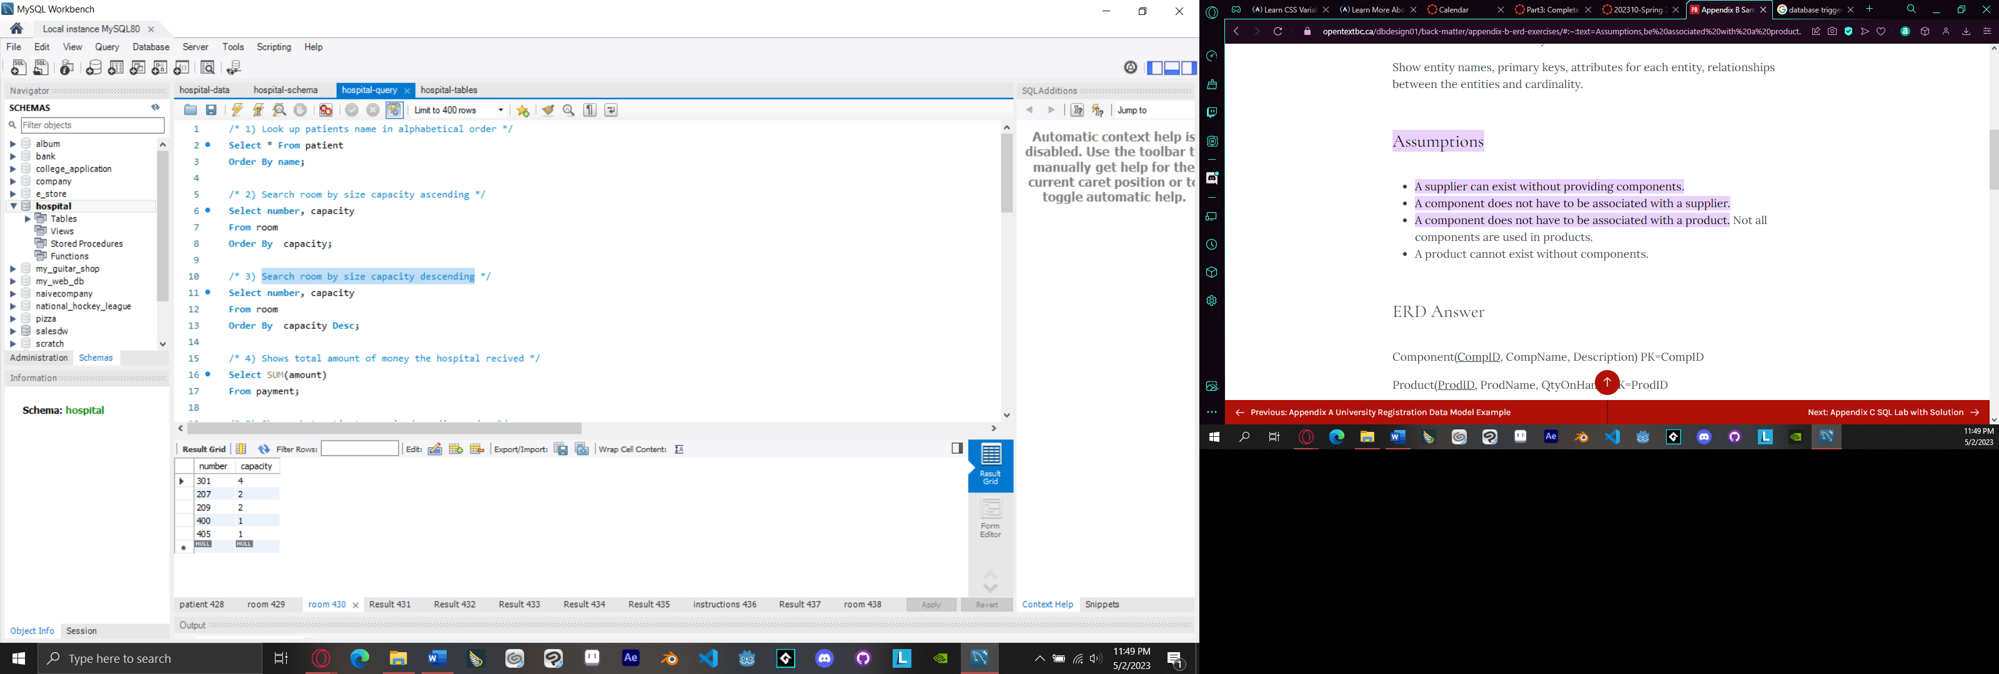

1. Shows total amount of money the hospital received

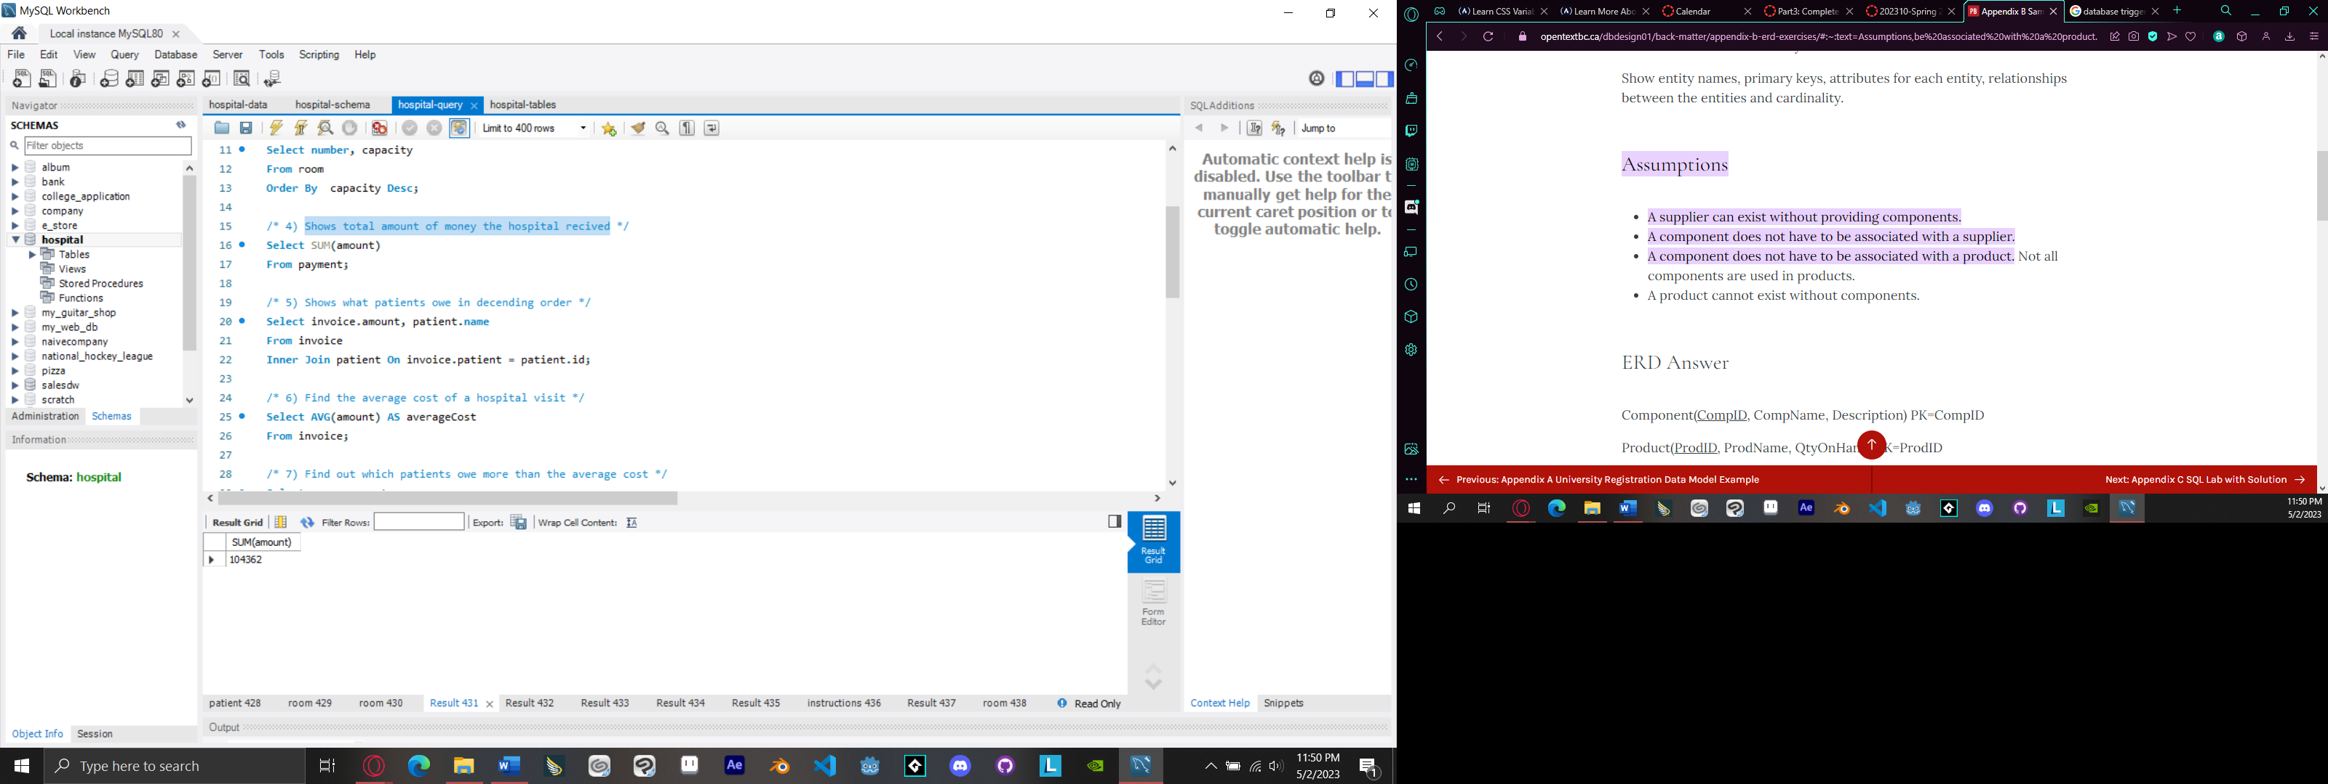

1. Shows what patients owe in descending order

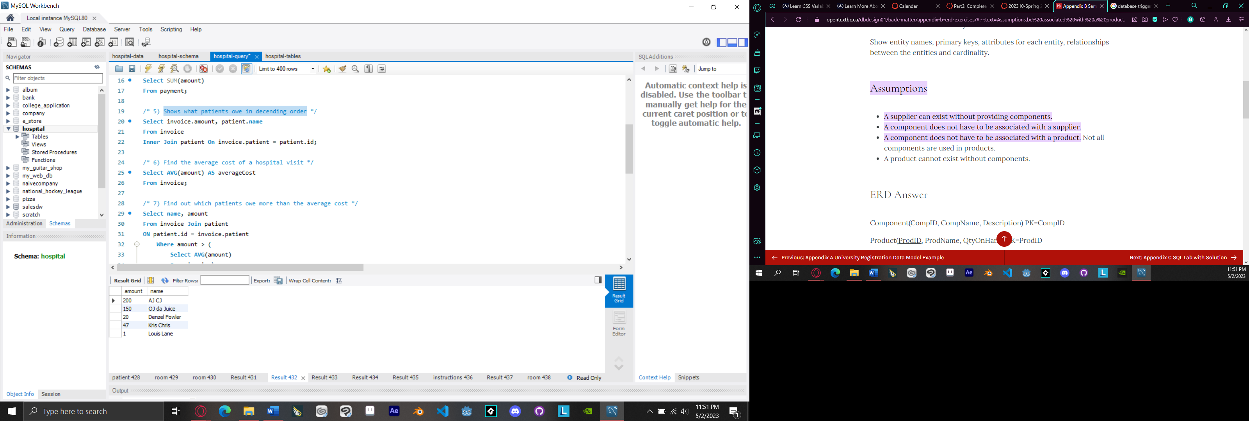

1. Find the average cost of a hospital visit

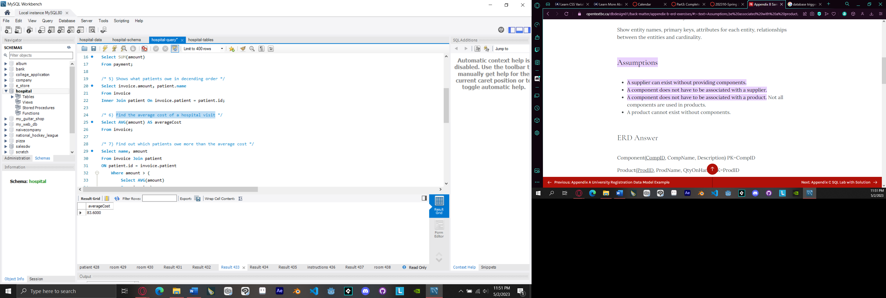

1. Find out which patients owe more than the average cost

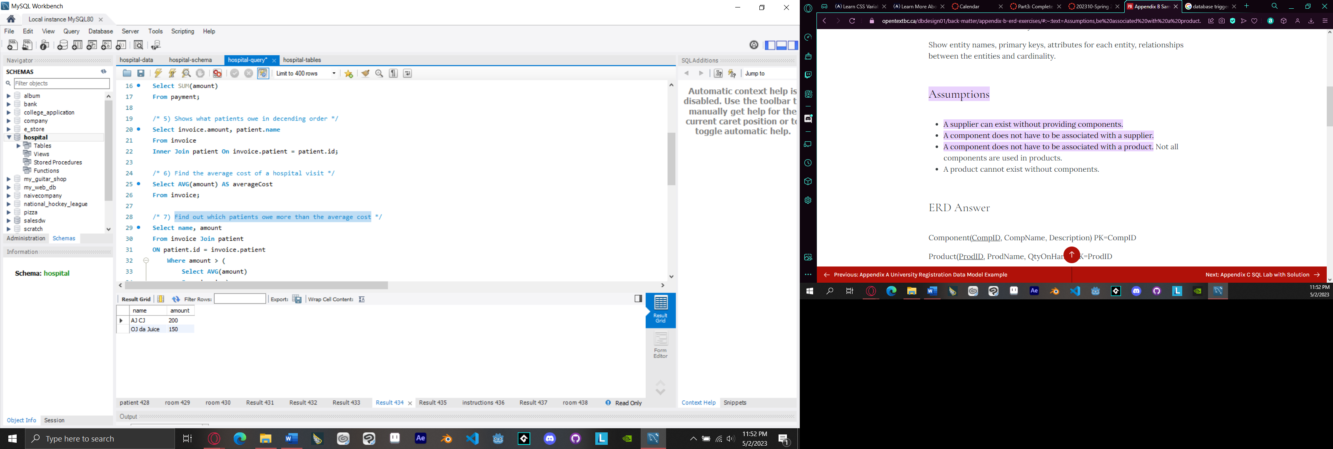

1. Find out which patients had surgery in the past

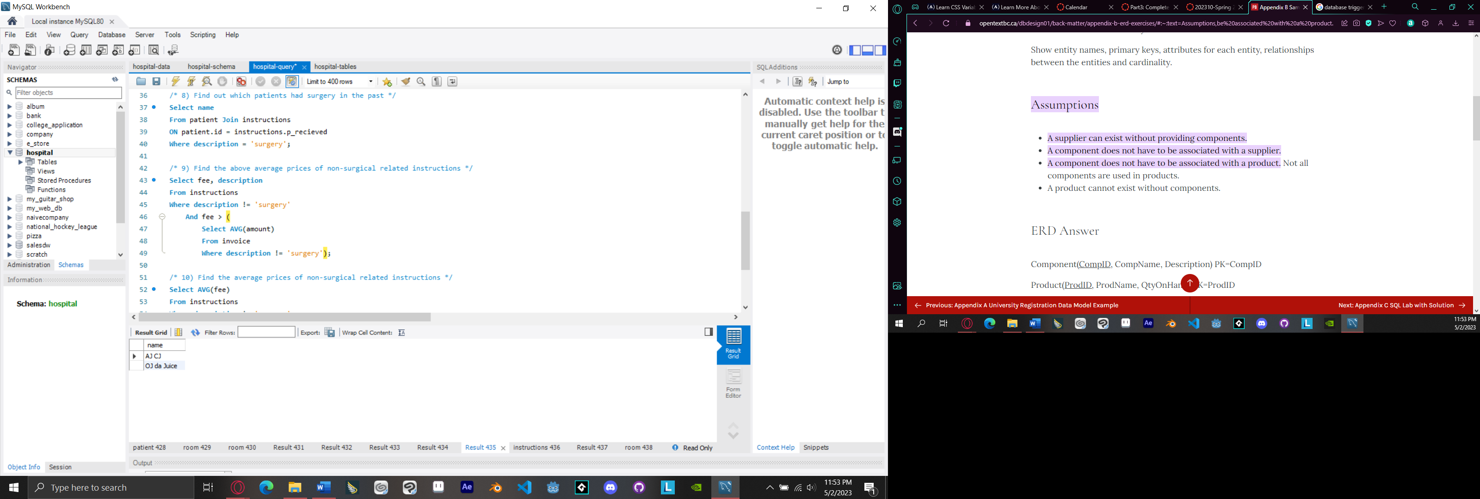

1. Find the above average prices of non-surgical related instructions

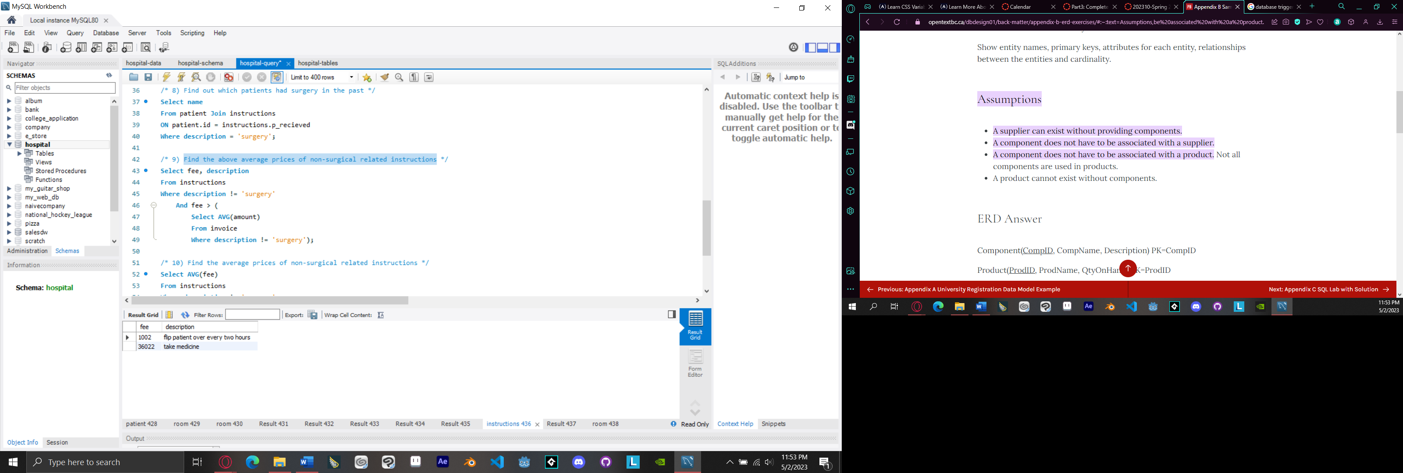

1. Find the average prices of non-surgical related instructions

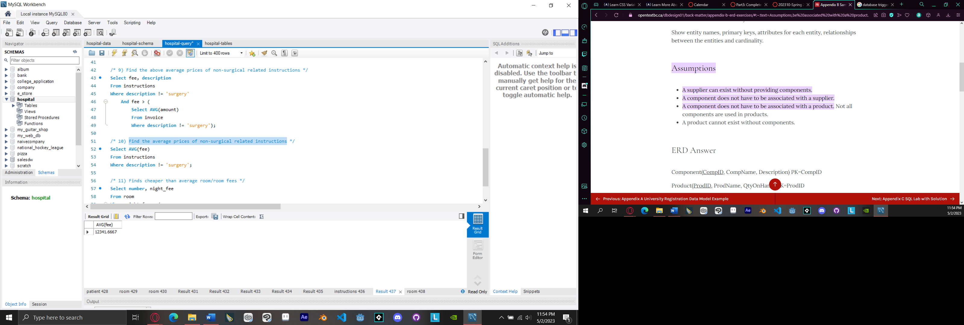

1. Finds cheaper than average room/room fees

